Project Design Phase-II Data Flow Diagram & User Stories
Date
Team ID
Project Name
Maximum Marks
30 September 2026
SWTID-2026-2220
Streamlining IT Procurement: Automating Standard Laptop Orders with Flow Designer
4 Marks

Data Flow Diagram:
A Data Flow Diagram (DFD) represents how information moves through the proposed IT procurement system. The diagram shows how an employee submits a standard laptop request, how Flow Designer routes and manages approval, and how IT/Procurement processes the approved order and updates its status.

Example: Level-0 Data Flow Diagram (Project Specific)
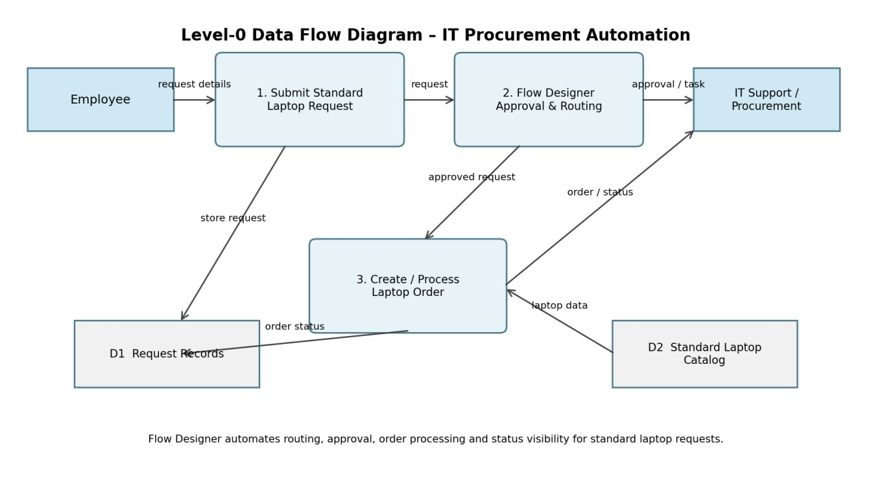
Key flow: Employee request → Flow Designer approval/routing → IT/Procurement processing → order/status update.

User Stories
Use the following user stories to describe the main functional requirements of the IT procurement automation project.
User Type |  | Functional  Requirement (Epic) | User Story ID | User Story / Task | Acceptance criteria | Priority | Release

Employee | Laptop Request | USN-1
Employee | Request Status | USN-2
Employee | Request Tracking | USN-3
IT Support | Approval Workflow | USN-4
IT Support | Request  Management | USN-5
Procurement/Admin | Order Processing | USN-6
Procurement/Admin | Order Status | USN-7
IT Support | Reporting | USN-8
As an employee, I can submit a standard laptop request with the required details so that the request can enter the automated procurement workflow.
As an employee, I can view the status of my laptop request so that I know whether it is submitted, approved, or being processed.
As an employee, I can receive workflow notifications for approval or processing updates so that I do not need repeated manual follow-up.
As IT support, I can review and approve standard laptop requests routed by Flow Designer so that eligible requests are processed consistently.
As IT support, I can view request details and update the processing status so that the employee has clear visibility.
As procurement/admin, I can process an approved standard laptop order using the standard laptop information so that manual data entry is reduced.
As procurement/admin, I can update the order status so that the employee and IT support can track progress.
As IT support, I can view request and order records so that repeated manual follow-up and errors are reduced.

I can submit a valid request and
receive a confirmation/status High Sprint-1
update.
The current request status is
visible and updated after workflow High Sprint-1
actions.
Notification is generated when the
request moves to the next Medium Sprint-2
workflow stage.
Approved requests move
automatically to the next stage; High Sprint-1
rejected requests are recorded.
Request details and status can be
High Sprint-1
updated and tracked.
Approved requests provide the
required laptop/order information High Sprint-2
for processing.
Status changes are stored against
Medium Sprint-2
the correct request.
Relevant request records can be
Low Sprint-3
reviewed with their latest status.

Project Goal: Automate standard laptop procurement requests using Flow Designer to reduce repetitive manual work, improve processing consistency, and provide clear request status visibility.

